Abstract Submission Form
Please submit your abstract by completing the abstract submission form. All fields are mandatory.
The abstracts should be sent to: polydays19@hzg.de Enter “Talk Submission” or “Poster Submission” in the subject line of your message. Please name your abstract MS Word file beginning with the word TALK or POSTER (depend on the type of presentation) and ending with your surname and first initial: e.g. TALK_Schmidt_S.docx.

Personal data of presenting author:
First name:

Last name:

Title:

Affiliation (University, Institute, Address, Postcode, City, Country):

Telephone:

E-mail:

Type of presentation (Oral or Poster):

Style for Abstract Title: Times New Roman, 14pt, Bold, Centered,
May Use More than One Line
Presenting Author’s Name underlinedª, Author’s Name^{b}
ªAuthors’ current affiliation address
^{b}Affiliation should be indicated by superscript letters

Keywords: please provide here 3-4 keywords

Body of abstract: Times New Roman, 12pt, justified, single spacing. The entire abstract including figures and references should not exceed one A4 page.
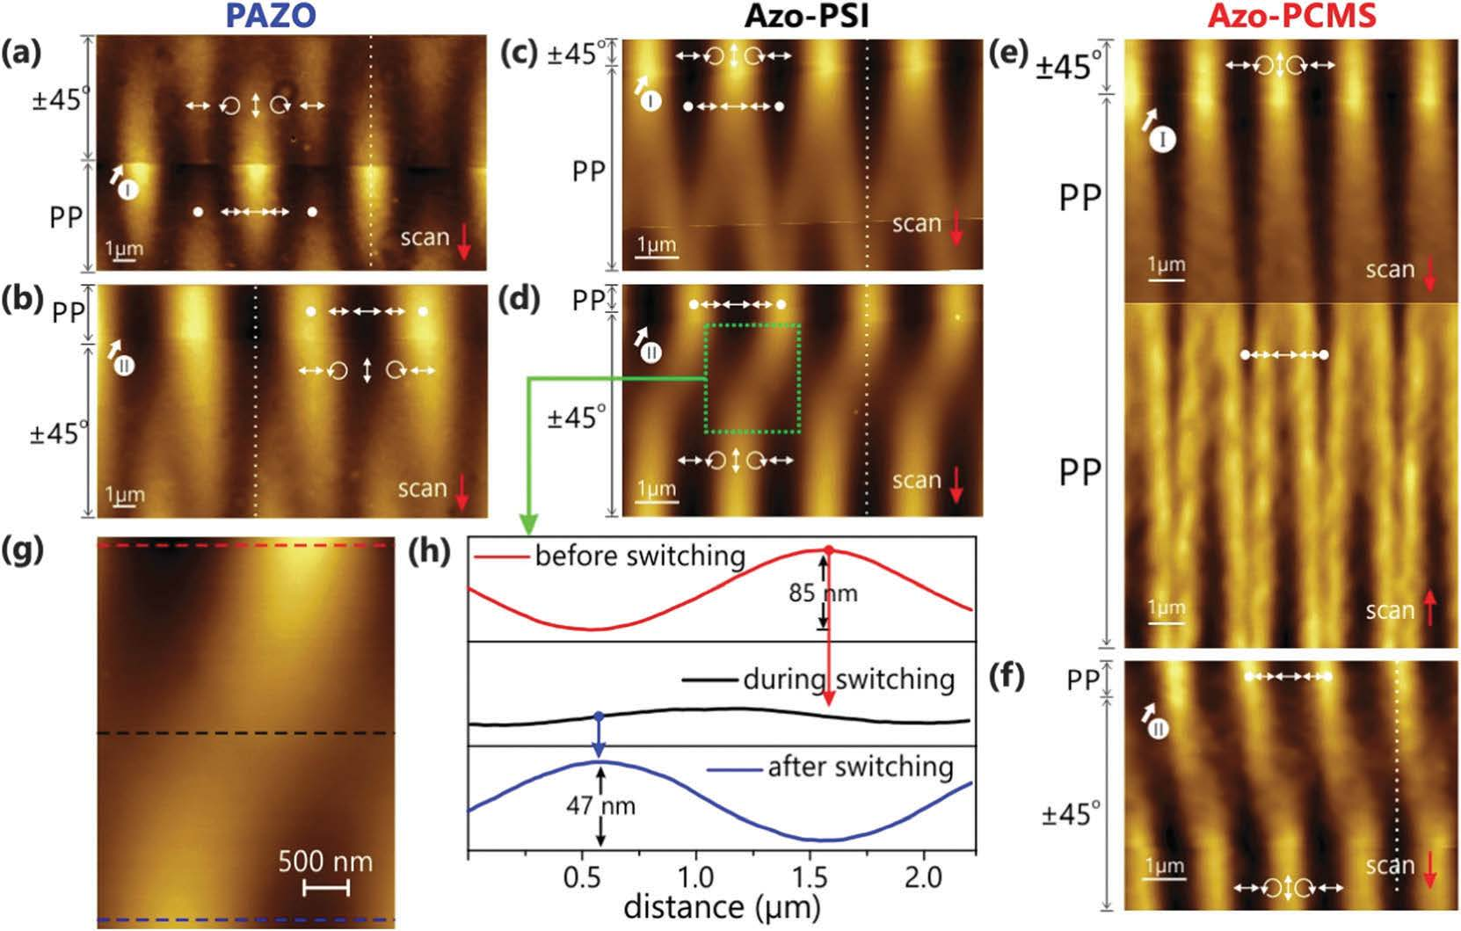
FIGURE 1. Style for figure captions: Times New Roman, 10 pt, justified. The text “FIGURE 1.” which labels the caption should be bold and capital.
References
[1] Should be justified to the left, cite as shown below
[2] Yadavalli, N. S.; Loebner, S.; Papke, Th.; Sava, E.; Hurduc, N.; Santer, S. A comparative study of photoinduced deformation in azobenzene containing polymer films. Soft Matter 2016, 12, 2593–2603.

